Australia Economic Accelerator Grants (AEA) – Ignite and Innovate Programs
Australia’s Economic Accelerator (AEA) promotes research translation and commercialisation capacity through the establishment these funding programs to invest in priority-driven objectives aligned with the National Reconstruction Fund. The AEA is part of the Australian Government’s University Research Commercialisation Action Plan and will initially run over ten years from 2023 to 2032. The AEA is designed to build a pipeline from discovery research through to commercialisation, ensuring Australia reaps the benefits of investment in research within the university sector.
AEA Ignite supports early-stage (TRL 3 to 5) research commercialisation through competitive grants of up to $500,000, for between three and 12 months, for universities to complete laboratory testing to establish “Proof-of-Concept”. This is the point at which basic research is complete, and testing has verified the concept, process, or prototype, at the laboratory scale. An industry partner is preferable but not required for the Ignite program. AEA Innovate supports commercialisation of projects that already have proof of concept and seek to demonstrate proof of scale or develop and test prototypes of products, processes or services (TRL 5 to 7). This highly competitive scheme provides up to $5million for up to 24 months. AEA Innovate requires an industry or investor partner who provides matching cash (at least 50% co-funding) and in-kind contributions.
Are you ready for these grants – what is required?
- ECU’s Commercial and Investment Services (CIS) office require some documentation to assess the alignment and readiness of the project to these grant schemes. Completion of an Invention Disclosure document is required as a first step. A portion of the information collected through the Invention Disclosure is transferrable to an AEA application.

Please note: If you think your research has commercial potential you can complete an Invention Disclosure form at any time and submit it to cis@ecu.edu.au for the CIS Team to consider. It is recommended that an Invention Disclosure is submitted prior to the funding round opening and at the point where you think that your research may have commercial potential.
- Is your project at the correct TRL (Technology Readiness Levels) – see guide.
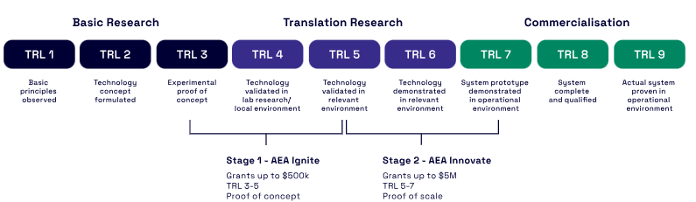

- Review the grant program guidelines (guidelines from previous rounds are available) to ensure that your project meets the eligibility criteria
- Does your project align to at least one of the priority-driven objectives of the National Reconstruction Fund? Each funding round will have a focus area that will include one or more of these priority-driven objectives. These focus areas will be identified in the scheme guidelines.
Note that applications will be accepted from focus areas not included in the funding round, however success rates from these non-aligned areas are very low.

TIMELINE
There is likely to be two rounds of both AEA Ignite and AEA Innovate per year – turnaround times are tight!
STEP 1 - complete an ECU Invention Disclosure document NOW and email to Commercial and Investment Services at cis@ecu.edu.au. The CIS team will provide assistance, guidance and feedback through this process. This is required for a grant application to progress to submission.
STEP 2 – CIS team review the Information Disclosure Form, seek any additional information, conduct some due diligence, and discuss the project with the Western Australian AEA Priority Manager. The CIS Team will discuss with you the suitability of your project and its current stage of development to the AEA grant schemes. You may be invited to subsequent discussions with the AEA representative.
STEP 3 – Submit an ECU RMS EOI, as soon as possible if you are progressing with an application.
STEP 4A - The applications require a Business Case. These need to be reviewed by CIS (10 working days before deadline).
STEP 4B - Work with the Pre-Award Team, within Research Services, for final reviews of the application, costings, pre-submission approvals and submission. You contact them via
Contacts: CIS Team cis@ecu.edu.au and Pre-Award Team – research-preaward@ecu.edu.au

