FIRST AIDERS
LIST FIRST AIDERS

FIRST AID BOXES
Location
CLOSEST DEFIBRILLATOR
Location
In an Emergency:
Call 000 then Security 6304 3333
FIRST AIDERS
LIST FIRST AIDERS

FIRST AID BOXES
Location
CLOSEST DEFIBRILLATOR
Location
In an Emergency:
Call 000 then Security 6304 3333
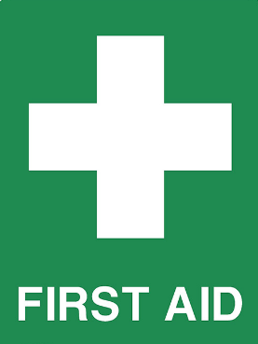

BUILDING AND FLOOR NUMBER

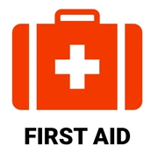

BUILDING AND FLOOR NUMBER

