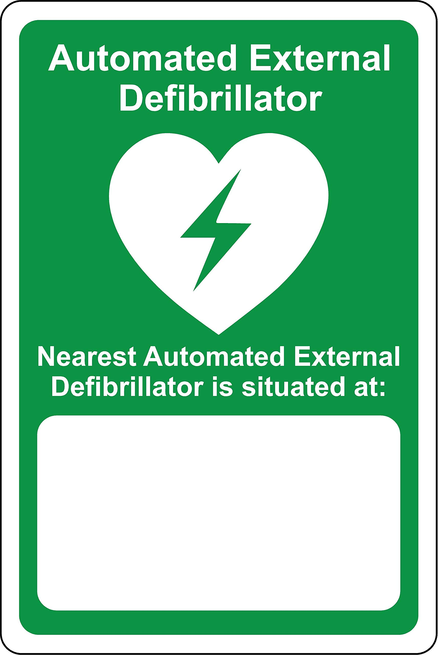
In a medical emergency, call Emergency
Services on 000 then ECU Security on 6304 3333
*Insert Location here*
(Building, Level, Room)

