

Step 1) Re-read your assignment and task instructions carefully

Check that you have answered the assessment question(s) as asked and that you have included all parts as outlined in the instructions and any marking guide/rubric. Make sure that you have correctly referenced all sources used in your work.

Step 2) Review the Turnitin similarity report

Submit at least 24 hours before the due date, so you have enough time to check the similarity report for any significant text matches that may need further paraphrasing before your final submission. You will not be able to resubmit after the due date has passed.

Step 3) Make sure you check that your assignment DOES NOT contain the types of academic misconduct below:
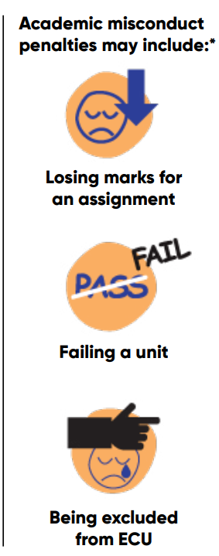

Plagiarism
- I have not copied and pasted from external sources without appropriate paraphrasing (or direct citation) AND referencing (in-text and end-text)
- My in-text and end-text citations follow ECU’s referencing guidelines
- I have not used my own previous work (without written permission from the Unit Coordinator) or other students’ previous assignment work in part or whole
- I have not used rephrasing/paraphrasing programs or tools or any other methods in order to conceal the use of other people’s intellectual property without citation

Collusion
- I have not worked with any other students on this assignment other than members of my group if it is a group assignment
- My assignment is not based on or derived from the work of any other student
- I have not provided other students with copies of my assignment work

Contract cheating
- I have not asked or paid someone to do this assignment for me
- I have not used any uncited content (including former student assessments) from a “study notes” or tutoring service/website such as chegg, studocu, coursehero, etc
- I have not received inappropriate assistance with this assignment from others

If evidence of any of these forms of academic misconduct is identified once your assessment has been submitted, a formal investigation process will commence. Always seek support or advice before submitting your assessment(s).

Support
ECU Academic Integrity

Avoiding Academic Misconduct

